An Application of Text Classification to Check a Product Review

by
Shuvashish Paul Sagar
Roll: 180194

A Thesis Report submitted to the institute of Information Technology
in partial fulfillment of the requirements for the degree of Masters of Science



Institute of Information Technology
Jahangirnagar University
Savar, Dhaka-1342
January 2020

CERTIFICATE

This is to certify that the thesis entitled An Application of Text Classification to Check a Product Review has been prepared and submitted by Roll: 180194 in partial fulfillment of the requirement for the degree of Master of Science (M.Sc.) in Information Technology on January 16, 2020.
Accepted and approved in partial fulfillment of the requirement for the degree Master of Science (M.Sc.) in Information Technology.

K M Akkas Ali Jesmin Akhter
Chairman Member

Dr. Md. Abu Yousuf Prof. Dr. Md. Mahbub Alam
Member Member (External)

DECLARATION

It is hereby declared, that this project or any part of it has not been submitted elsewhere for the award of any degree or diploma.

Shuvashish Paul Sagar
Roll: 180194

Acknowledgements

I feel grateful to and wish our profound indebtedness to Md. Fazlul Karim Patwary Professor, Institute of Information Technology (IIT), Jahangirnagar University, Savar, Dhaka. Deep Knowledge & keen interest of my supervisor in the field of Data Science and Big Data influenced me to carry out this project. His endless patience, scholarly guidance, continual encouragement, constant and energetic supervision, constructive criticism, valuable advice, reading many inferior draft and correcting them at all stage have made it possible to complete this project. Heartiest gratefulness to Dr. M, Mesbahuddin Sarker, Director, IIT, JU, who gave me the golden opportunity to do this wonderful project on the topic “An Application of Text Classification to Check a Product Review”, which also helped me in doing a lot of research and I came to know about so many new things I am really thankful to them.
Secondly, I would also like to thank my project-mates who helped me a lot in finalizing this project within the limited time frame.
Finally, I would like to acknowledge my most affectionate and respective parents for being with me always. Many thanks for my beloved wife for being so supportive. Last but not the least, I pay my gratitude to my office colleague for cooperating me while implementing this project.

Abstract

The term ‘distributed file system’ describes innovative techniques and technologies to capture, store, distribute, manage and analyze petabyte or larger-sized datasets with high-velocity and different structures. In order to process these large amounts of data in an inexpensive and efficient way, HDFS is used. HDFS is an open source project that enables the distributed processing of large data sets across clusters of commodity servers. It is designed to scale up from a single server to thousands of machines, with a very high degree of fault tolerance.
Secured and optimized distributed file system for ISP user log analysis is a centralized log analytics platform that supports collaboration in a distributed environment. Distributed File System for ISP log provides a uniform name space for all ISP along with location independence and location transparency. Any user’s internet access log can be accessed and analyzed using apache sparks data brick file system on stored log in DFS. At first, limitation of popular DFS like NFS and CIFS will be explored. ISP log management, DFS file architecture and security is considered for designing proposed ISP log management system. Finally, simulation on proposed distributed file system and query processing will be performed to obtain the desired result related to optimization and security of the proposed distributed log analysis system.
It is hoped this project will help central regulatory body to enhance cyber security and governance of internet usage in Bangladesh.

Table of Contents

Title page
Certification |  |  |  |  |  |  | i
Declaration |  |  |  |  |  |  | ii
Acknowledgements |  |  |  |  |  |  | iii
Abstract |  |  |  |  |  |  | iv
Table of Contents |  |  |  |  |  |  | v
List of Tables |  |  |  |  |  |  | viii
List of Figures |  |  |  |  |  |  | ix
List of Symbols |  |  |  |  |  |  | x
List of Abbreviations |  |  |  |  |  |  | xi
Chapter 1 | Introduction |  |  |  |  | 1
 | 1.1 Introduction to Log Management |  |  |  |  | 1
 | 1.2 Distributed file system |  |  |  |  | 1
 | 1.3 Access control policy |  |  |  |  | 2
 | 1.4 Limitations of distributed file system |  |  |  |  | 2
 |  | 1.4.1 Limitations of NFS |  |  |  | 2
 |  | 1.4.2 Limitations of CIFS |  |  |  | 3
 |  | 1.4.3 Limitations of AFS |  |  |  | 3
 |  | 1.4.4 Limitations of XFS |  |  |  | 4
 |  | 1.4.5 Limitations of Samba |  |  |  | 4
 | 1.5 Motivation of the project |  |  |  |  | 4
 | 1.6 Objectives of the project |  |  |  |  | 5
 | 1.7 Outline of the Project Paper |  |  |  |  | 5
Chapter 2 | Literature Review |  |  |  |  | 7
 | 2.1 Related works in ISP log and distributed file system |  |  |  |  | 7
 | 2.2 ISP log format and mandate |  |  |  |  | 7
 | 2.3 Hadoop distributed file system (HDFS) |  |  |  |  | 10
 |  | 2.3.1 Salient features of HDFS |  |  |  | 11
 |  | 2.3.2 Map reduce algorithm |  |  |  | 14
 |  | 2.3.3 Flow of map reduce algorithm |  |  |  | 14
 | 2.4 No-sql query processing tool on DFS |  |  |  |  | 15
 | 2.5 Security Solution for Distributed File System |  |  |  |  | 16
Chapter 3 | Proposed System Architecture |  |  |  |  | 17
 | 3.1 Proposed DFS |  |  |  |  | 17
 | 3.2 Log analysis over DFS |  |  |  |  | 19
 | 3.3 Access control policy implementation |  |  |  |  | 20
 | 3.4 Security features of DFS |  |  |  |  | 21
 | 3.5 Environment setup and optimization |  |  |  |  | 22
 | 3.6 Data protection |  |  |  |  | 23
 | 3.7 Proposed log format for ISP |  |  |  |  | 24
Chapter 4 | Implementation |  |  |  |  | 26
 | 4.1 Introduction |  |  |  |  | 26
 | 4.2 DFS cluster environment |  |  |  |  | 26
 | 4.3 Configuring master node |  |  |  |  | 27
 |  |  | 4.3.1 Host file configuration |  |  | 27
 |  |  | 4.3.2 Key-based SSH authentication setup |  |  | 27
 |  |  | 4.3.3 User profile configuration |  |  | 28
 |  |  | 4.3.4 Set java home |  |  | 29
 |  |  | 4.3.5 ISP log analytics core site configuration |  |  | 29
 |  |  | 4.3.6 Synchronization of binary and data directory |  |  | 29
 |  |  | 4.3.7 Configuration of data block replication parameter |  |  | 29
 |  |  | 4.3.8 Configuration of yarn as job scheduler |  |  | 30
 | 4.4 Configuration of Data Nodes |  |  |  |  | 31
 | 4.5 Apache spark configuration |  |  |  |  | 32
 | 4.6 Implementation of access control using apache ranger |  |  |  |  | 33
 | 4.7 Secured connectivity among Nodes |  |  |  |  | 34
 | 4.8 Setup and configure NFS for benchmarking |  |  |  |  | 35
Chapter 5 | Simulation and Result |  |  |  |  |  | 36
 | 5.1 Introduction |  |  |  |  |  | 36
 | 5.2 Data collection |  |  |  |  |  | 36
 | 5.3 Monitor HDFS cluster |  |  |  |  |  | 37
 | 5.4 Experiments with Proposed Method |  |  |  |  |  | 38
 | 5.5 Comparison between proposed method and map reduce |  |  |  |  |  | 39
 | 5.6 Comparison with present scenario of ISP log |  |  |  |  |  | 40
 | 5.7 Monitor access to ISP log analytics using proposed solution |  |  |  |  |  | 41
 | 5.8 Performance benchmarking of Proposed DFS over NFS and CIFS |  |  |  |  |  | 42
 | 5.9 Security comparison among NFS,CIFS and HDFS |  |  |  |  |  | 43
Chapter 6 | Conclusions and Future Works |  |  |  |  |  | 44
 | 6.1 Conclusion |  |  |  |  |  | 44
 | 6.2 Major contribution and recommendation for future works |  |  |  |  |  | 44
References |  |  |  |  |  |  | 46

List of Tables

Table 2.1 | ISP user access log | 8
Table 2.2 | Syslog format | 8
Table 2.3 | ISP IPDR log format | 9
Table 3.1 | ISP log analytics Name Node and Data Node information | 18
Table 3.2 | Proposed log format | 24
Table 5.1 | Sample ISP user internet activity log | 36
Table 5.2 | Scala output of clients connected with pop name | 38
Table 5.3 | Security comparison among NFS, CIFS and HDFS | 43

List of Figures
Fig. 2.1 | Flow of map reduce algorithm | 15
Fig. 3.1 | Proposed DFS’s network architecture | 17
Fig. 3.2 | Proposed distributed file system | 18
Fig. 3.3 | Proposed security policy management | 21
Fig. 3.4 | Proposed DFS access control policy | 23
Fig. 3.5 | ISP log merge script | 25
Fig. 4.1 | Kernel and Java version of master and slave nodes | 26
Fig. 4.2 | Name and Data Node host file | 27
Fig. 4.3 | User profile configuration | 28
Fig. 4.4 | Spark user profile | 28
Fig. 4.5 | Core site configuration | 29
Fig. 4.6 | HDFS site configuration | 30
Fig. 4.7 | Mapred-site configuration | 30
Fig. 4.8 | Yarn site configuration | 31
Fig. 4.9 | Slave node configuration | 31
Fig. 4.10 | CSV databrick loading configuration | 32
Fig. 4.11 | Apache spark web gui | 32
Fig. 4.12 | Log analytics access control policy’s dash board | 33
Fig. 4.13 | Log analytics user and group information | 33
Fig. 4.14 | IPSec over GRE tunnel configuration between master and ISP | 34
Fig. 5.1 | HDFS cluster monitoring | 37
Fig. 5.2 | Scala output of apache spark framework for MAC based query | 39
Fig. 5.3 | Comparison between proposed method and map reduce (3 Instances) | 40
Fig. 5.4 | User activity monitor | 41
Fig. 5.5 | Read latency of proposed DFS, CIFS and NFS | 42
Fig. 5.5 | Write latency of proposed DFS, CIFS and NFS | 42

List of Symbols

 | Router
 | Switch
 | Cloud
 | Connectivity
 | Server
 | Hadoop
 | Spark framework
 | Firewall

List of Abbreviations and Acronyms

ISP Internet Service Provider
DFS Distributed File System
HDFS Hadoop Distributed File System
ACP Access Control Policy
NTP Network Time Protocol
IoT Internet of Things
BTRC Bangladesh Telecommunication Regulatory Commission
BWA Broadband Wireless Access
IPDR IP Address Data Record
SSH Secure Shell
SHA Secure Hash Algorithm
GUI Graphical User Interface
SQL Structured Query Language
POP Point of Presence
Wi-Fi Wireless Fidelity
WIMAX Worldwide Interoperability for Microwave Access
LTE Long Term Evaluation
IP Internet Protocol
MAC Media Access Control
JDK Java Development Kit
XML Extensible Markup Language
RAM Random Access Memory
API Application Programming Interface
CSV Comma Separated Value

CHAPTER ONE
INTRODUCTION
1.1 Introduction to Log Management
From a security point of view, the purpose of a log is to act as a red flag to detect suspicious activity. Reviewing logs could help identify malicious activities on any system. The primary drivers for log management implementations are concerns about security, system and network operations and regulatory compliance. Given the large amount of log data generated by systems, it is impractical to preserve and review all of these logs manually each day. Effectively analyzing large volumes of diverse logs can pose many challenges, such as:
Volume: log data can reach hundreds of gigabytes of data per day for a large organization.
Normalization: logs are produced in multiple formats. The process of normalization is designed to provide a common output for analysis from diverse sources.
Velocity: The speed at which logs are produced from devices can make collection and aggregation difficult.
Veracity: Log events may not be accurate. This is especially problematic from systems that perform detection, such as intrusion detection systems.
Users and administrators of log management systems may purchase complete commercial tools or build their own log-management and intelligence tools, assembling the functionality from various open-source components, or acquire systems from commercial vendors. Log management is a complicated process and organizations often make mistakes while approaching it.

1.2 Distributed File System
A distributed file system (DFS) is a file system with data stored on multiple servers [1]. The data is accessed and processed as if it was stored on the local client machine. The DFS makes it convenient to share information and files among users on a network in a controlled and authorized way. The server allows the client users to share files and store data just like they are storing the information locally. However, the servers have full control over the data and give access control to the clients.
1.3 Access Control Policy
The collection of mechanism and procedures that permit managers of a system to exercise a directing or restraining influence (grants or revokes rights) over the behavior, use and content of a system and/or its data. Access control permits management to specify what users or processes can do, which resources they can access and what operations they can perform on a system.
Access Control Concepts
- Subject: Anything desiring access to an object (person, process, etc.).
- Object: Anything that contains data (file system, building, database, etc.).
- System: Processes, Procedures and Controls in place to enforce access rules. (Physical, Hardware, Software, Policy, Network, etc.).
Access Control Services
- Identification: object claims identity.
- Authentication: object proves claim.
- Authorization: what the object is allowed to do (matrix).
- Auditing (audit logs): tracks what the object does.
- Accountability: linking human activities to online identity.
f. Non repudiation: cannot deny that the event occurred.
1.4 Limitations of Distributed File System
1.4.1 Limitations of NFS
The NFS protocol was developed by Sun Microsystems in 1984 [2]. NFS provides a distributed file system which allows any computer to access files stored remotely in the same manner as a file on the local hard drive. NFS is built on the Open Network Computing Remote Procedure Call (ON RPC), described in RFC 1831. Version 2 of NFS was stateless and ran over UDP. Version 3 introduced support for TCP. Finally, version 4 introduced a stateful protocol. Though NFS is strongly associated with unix, it can be used on Windows, Mac and Novell Netware.
An NFS server can mount directories that are exported by other NFS servers. However, it cannot export share to its clients. The client will have explicitly mounted it from the other server. On the other hand, a file system can be mounted over another file system that is not a local one, but rather is a remotely mounted one. NFS supports location transparency but not location independence. This is due to its decision not to enforce a common name space. This makes it harder to share files.

1.4.2 Limitations of CIFS
In its original incarnation as Server Message Block (SMB), it was invented by IBM to provide a genuine networked file system. Microsoft modified it heavily, adding support for symbolic links, hard links and large files and launched an initiative to rename it as CIFS. CIFS can run on top of both NetBIOS and TCP/IP protocols. In the manner of other distributed file systems, CIFS uses a client-server model for communication. In contrast to other file systems discussed, CIFS also provide inter-process communication (named pipes). In addition, SMB servers can share other resources besides file systems.
CIFS cannot really be described as a legitimate distributed system. It merely provides a way to access resources over a network. It does not provide either location transparency or location independence. Resources are identified as server-name followed by path-to-resource. Unlike other distributed file systems, it makes little effort to remain agnostic of the underlying operating system. There is no concurrency control or caching. It does not support file replication or migration. It does provide unix consistency semantics because the file has only one copy.

1.4.3 Limitations of AFS
The Andrew File System (AFS) is a distributed file system which uses a set of trusted servers to present a homogeneous, location transparent file name space to all the client workstations. It was developed by Carnegie Mellon University as part of the Andrew Project. Originally named as "Vice", AFS is named after Andrew Carnegie and Andrew Mellon. AFS has been used by distributed computing.
AFS does not use unix file semantics. AFS only supports directory permissions which may confuse those who are used to the standard unix chmod permission sets. AFS permissions only work for directories right now, however, future version promises to support file permissions as well. The need to authenticate everything and everyone may sometimes cause problems for people who have no idea how to handle authentication. Hopefully, this will change as security becomes a bigger issue and people realize the need for more authentication. Special files used in standard unix not supported. These include hard links and device files.

1.4.4 Limitations of XFS
XFS is a high-performance 64-bit journaling file system created by Silicon Graphics and ported to the Linux kernel. XFS is supported by most Linux distributions, some of which use it as the default file system. The XFS file system is a high-performance journaling file system. XFS is the default file system for Red Hat Linux 7. XFS supports a maximum file system size of 500 TB and a maximum file size of 16 TB.
An XFS file system can be shrunk only by backing up, re-installing, and restoring, e.g. using xfsdump and xfsrestore. An easier method would be useful, for example, in some virtualized environments. No support for transparent data compression and no checksum protection against silent data corruption.

1.4.5 Limitations of Samba
Samba is a free software re-implementation of the SMB networking protocol and was originally developed by Andrew Tridgell. Samba provides file and print services for various Microsoft Windows clients and can integrate with a Microsoft Windows server domain either as a domain controller (DC) or as a domain member. Samba runs on most unix systems, OpenVMS and unix-like systems such as Linux, Solaris, AIX and the BSD variants including Apple's mac OS server and mac OS client. Interaction with other versions of samba can be difficult and it uses netbios which is not the world’s most efficient network protocol.

1.5 Motivation of the Project
De-centralized ISP log management and lack of standard for ISP log format and retention has motivated us to design and implement a centralized log management system where hadoop distributed file system will be implemented due to limitation of other popular distributed file systems namely NFS and CIFS. Apache spark performs faster than map reduce on executing no-sql query and ranger security suite provides best access control across distributed file system.

1.6 Objectives of the Project
Considering the volume and necessity of ISP user’s log, objective of the project were set as below:
- Review features of all DFS. Choose highly reliable, reselient DFS for big data.
- Review and analysis of log mandate, format and propose a common log format.
- Security of proposed DFS. Ensure confidentiality of stored log, integrity and availability of proposed DFS.
- Optimization and implementation of proposed DFS with 3 nodes.
- Log analysis and perform simulation to obtain desired results like best performance of read, write latency and security features.

1.7 Outline of the Project
ISP log analytics design and implementation includes installation of 1 primary name node, 1 secondary name node with 3 slaves or Data Nodes for distributed files systems to simulate proposed DFS and log analysis. The primary and secondary name node will work as Master node with high availability feature where all ISP log servers will be connected to form distributed file systems. 3 slave nodes shall work as ISP log servers.
VMWARE ESXI version 6 virtual environment shall be used to host primary and secondary name node and 3 Data Nodes. Master node will be configured from node 1 named as debian and 3 slave nodes will be configured from debian, node 2 and node 3 respectively. After completion of master and slave nodes in debian linux version 8 operating system and OpenJDK, Hadoop distributed file systems using HDFS, yarn, master and slave node configuration will be completed. At master node namely debian, configuration of core site, yarn, host and slave file will be modified before formatting the distributed file system. For quick recovery of system, snapshot of all virtual servers will be preserved. A new user named as ‘hadoop user’ shall be created and where default location of java, hadoop binary and data directory location will be defined. In order to facilitate cluster node communication among all 3 servers, we will configure password less ssh-key based connectivity. Once the ssh-key based communication is established, all hadoop data and binary directory with profile setting will be copied from master node to all slave nodes.
At next step all Data Node will be formatted to build distributed file system and start the DFS cluster. After formatting the designed file system, we will test access to the analytics server from local console and Web GUI. After completion of necessary customization, sampled ISP log will be uploaded to DFS for processing. Apache Spark framework will be installed and configured with Data brick file system upon existing distributed infrastructure to perform no sql query on user’s session log.
In order to perform criteria based search in our developed system, we will execute sql like query to check any specific user’s activity to derive user’s name, contact details, POP location, and access time. Based on query result, we will determine our system’s accuracy.
In order to deploy access control policy to ensure authorized access to the system, Apache Ranger 0.5.4 will be integrated to ISP log analytics’ distributed file system. Log processing and analysis performance using proposed spark utility will be compared to that of popular map reduce algorithm. At the end, performance of proposed DFS with 2 commonly used DFS namely NFS and CIFS will be performed.

CHAPTER TWO
LITERATURE REVIEW

2.1 Related Works in ISP Log and Distributed File System
Deepa et al. state that the components of HDFS file system, Big Data and processing of this terabytes to multiple petabytes which will help to manage and process large volume of data [4]. And also addresses the fundamental of HDFS file system with architecture and challenges. It is also mentioned how storing less number of larger files rather than huge number of smaller files.
V. Sajwan et al. state about HDFS architecture, name node and Data Node configuration [5]. HDFS is designed and developed to scale up from a one server to thousands of machines device with extremely high degree blame of ability this paper provides a survey and view of the use of HDFS in different types of usability.
BTRC has described about ISP license and internet user statistics. This is about the total number of internet subscribers which has already reached 92.466 Million at the end of October, 2018 [6]. This survey provides a clear view of necessity of centralized log server for keeping the track of internet usage.
CoreStack addresses the initiative to improve transparency of ISPs in India [7]. This paper will describe how to preserve access log for all users and share log files with central regulatory body.

2.2 ISP Log Format and Mandate
Internet has become a part and parcel of our life. Most people are connected to internet for 24 hours using BWA and WIFI device which in turn connects to local ISP and WIMAX/3G/LTE/4G internet service provider. Local ISP’s are maintaining their own log servers [8] where customers’ internet session is logged using different format. Some ISP are maintaining log as below format of Table 2.1. From the Table 2.1, the ISP is storing log with access time, user’s laptop or wifi MAC address, a short user id, the translated real IP, user name, address and contact number.

Table 2.1: ISP User Access log
Date Time | MAC | User | NAT IP | NAME | Address | Contact
09/09/2018 21:04 | C4:71:54:2D:0B:B7 | enam | 103.73.105.108 | Enamul Kabir | Flat# 2tola/Left, Building# 725-Koppat Mation, | 1914132338
09/09/2018 21:04 | 18:A6:F7:79:FB:D1 | jibon | 103.73.105.108 | Jibon Chakma | Flat# 702, Building# 401-Hazira Villa, Goli | 1533107790
09/09/2018 21:04 | 70:4F:57:D7:F4:61 | Kaiser | 103.73.105.108 | Md. Kaiser Hasan | Flat# 5th Floor D2, Building# 105-Hill Paradise. | 1818069309
09/09/2018 21:04 | AC:84:C6:2B:D5:B9 | jibon1 | 103.73.105.108 | Jibon | Flat# 3rd Floor, Building# 03-Doctor abu taher. | 1630639872

The Indian ISPs have to adhere to the 2013 missives issued by the Department of Telecommunications (DoT). In its initiative to improve transparency, the DoT had mandated ISPs to maintain logs of Internet Protocol Detail Record (IPDR) and Network Address Translation (NAT). The directive also instructed storage of log data using format as Table 2.2 and Table 2.3 for one year by every ISP owner itself.

Table 2.2: Syslog format
SN | Parameter to be stored in SYS log of Network Address Translation (NAT) | Remarks
1 | Start date(mm:dd:yyyy) and time(hh:mm:ss) | Timestamp
2 | End date(mm:dd:yyyy) and time(hh:mm:ss) | Timestamp
3 | Source IP Address | IP address of client
4 | Source Port | Used port
5 | Translated IP Address | Natted real IP address
SN | Parameter to be stored in SYS log of Network Address Translation (NAT) | Remarks
6 | Translated Port | Natted port
7 | Destination IP Address | Target IP address
8 | Destination Port | Target port

Table 2.3: ISP IPDR log format
SN | Field attribute | Remarks
1 | Name of Person / Organization | User name
2 | Address | User address
3 | Contact No | User contact no.
4 | Email Address | User email address
5 | User ID for Internet Access based on authentication | User identification no.
6 | Static / Dynamic IP Address Allocation | Assigned IP address
7 | Source port of the public IP address in case of NATING | Source port
8 | IST Start Time of IP Address Allocation (hh:mm:ss) | Timestamp
9 | IST End Time of IP Address Allocation (hh:mm:ss) | Timestamp
10 | Source MAC Address / Other Device Information Number | User MAC address

European Union defined scope on the retention of data generated or processed in connection with the provision of publicly available electronic communications services or of public communications networks and amending Directive 2002/58/EC. Several member states have adopted legislation providing for the retention of data by service providers for the prevention, investigation, detection, and prosecution of criminal offences. Those national provisions vary considerably. Member states shall ensure that the categories of data specified are retained for periods of not less than six months and not more than two years from the date of the communication [9].
It is found that ISP does not maintain customer profile properly for logging their activities. Some ISP starts operation without permission of BTRC and operates with limited insecure system resources. ISPAB (Internet Service Providers Association Bangladesh) has enrolled only limited number of ISPs as members [10].
The ISP administrator can access the log and it is easy to modify contents for him to disclose the log if it is required by any law governing organization. ISP may include the POP location of the user. User’s access log may not be preserved for a long duration and ISP do not maintain any backup device to store offsite copy of user log. Considering the present scenario, we would like to propose a common log format for all ISP which will be more descriptive and access control policy will be developed to view, edit and preserve access right’s. Besides there will be at least 2 more copies of each ISP user log in a distributed file system where legitimate Administrator and personnel will get limited and administrative access only when required. Now a days, people are connecting to internet using smart phone, tab and these devices security lock is broken frequently by expert technicians and used for crime and other intended activities. Our proposed distributed file system will provide a convenient means to search for any smart device that connects to internet after reported as missing or stolen. The suspected device can be located using its recent IP Address, MAC, POP location, User ID and Name. If there is no SIM card in any stolen phone, there will be no record in Mobile tracking by mobile operator but the device can be located easily by its recently used IP when it connects to web through WI-FI, WIMAX and LTE with the help of APPLE and Google user’s identification.

2.3 Hadoop Distributed File System (HDFS)
HDFS is a distributed file system designed to run on commodity hardware. It has many similarities with existing distributed file systems. However, the differences from other distributed file systems are significant. HDFS [11] is highly fault-tolerant and is designed to be deployed on low-cost hardware. HDFS provides high throughput access to application data and is suitable for applications that have large data sets. HDFS relaxes a few POSIX requirements to enable streaming access to file system data. HDFS was originally built as infrastructure for the apache nutch web search engine project. HDFS is now an Apache Hadoop subproject.

2.3.1 Salient Features of HDFS
- Hardware Failure
Hardware failure is the norm rather than the exception. An HDFS instance may consist of hundreds or thousands of server machines, each storing part of the file system’s data. The fact that there are a huge number of components and that each component has a non-trivial probability of failure means that some component of HDFS is always non-functional. Therefore, detection of faults and quick, automatic recovery from them is a core architectural goal of HDFS [11].
- Streaming Data Access
Applications that run on HDFS need streaming access to their data sets. They are not general purpose applications that typically run on general purpose file systems. HDFS is designed more for batch processing rather than interactive use by users. The emphasis is on high throughput of data access rather than low latency of data access. POSIX [12] imposes many hard requirements that are not needed for applications that are targeted for HDFS. POSIX semantics in a few key areas has been traded to increase data throughput rates.
- Large data set
Applications that run on HDFS have large data sets. A typical file in HDFS is gigabytes to terabytes in size. Thus, HDFS is tuned to support large files. It should provide high aggregate data bandwidth and scale to hundreds of nodes in a single cluster. It should support tens of millions of files in a single instance.
- Simple Coherency Model
HDFS applications need a write-once-read-many access model for files. A file once created, written, and closed need not be changed. This assumption simplifies data coherency issues and enables high throughput data access. A Map Reduce application or a web crawler application fits perfectly with this model.
- Data Replication
HDFS is designed to reliably store very large files across machines in a large cluster. It stores each file as a sequence of blocks; all blocks in a file except the last block are the same size. The blocks of a file are replicated for fault tolerance. The block size and replication factor are configurable per file. An application can specify the number of replicas of a file. The replication factor can be specified at file creation time and can be changed later. Files in HDFS are writing-once and have strictly one writer at any time.
The Name Node makes all decisions regarding replication of blocks. It periodically receives a heartbeat and a block report from each of the Data Nodes in the cluster. Receipt of a heartbeat implies that the Data Node is functioning properly. A block report contains a list of all blocks on a Data Node.
- Safe mode
On startup, the Name Node enters a special state called Safe mode. Replication of data blocks does not occur when the Name Node is in the Safe mode state. The Name Node receives Heartbeat and block report messages from the Data Nodes. A block report contains the list of data blocks that a Data Node is hosting. Each block has a specified minimum number of replicas. A block is considered safely replicated when the minimum number of replicas of that data block has checked in with the Name Node. After a configurable percentage of safely replicated data blocks checks in with the Name Node (plus an additional 30 seconds), the Name Node exits the Safe mode state. It then determines the list of data blocks (if any) that still have fewer than the specified number of replicas. The Name Node then replicates these blocks to other Data Nodes.
- The Communication Protocol
All HDFS communication protocols are layered on top of the TCP/IP [13] protocol. A client establishes a connection to a configurable TCP port on the Name Node machine. It talks the Client Protocol with the Name Node. The Data Nodes talk to the Name Node using the Data Node Protocol. A remote procedure call (RPC) [14] abstraction wraps both the client protocol and the Data Node protocol. By design, the Name Node never initiates any RPCs. Instead, it only responds to RPC requests issued by Data Nodes or clients.
- Robustness
The primary objective of HDFS is to store data reliably even in the presence of failures. The three common types of failures are Name Node failures, Data Node failures and network partitions.
- Data Disk Failure, Heartbeats and Re-Replication
Each Data Node sends a heartbeat message to the Name Node periodically. A network partition can cause a subset of Data Nodes to lose connectivity with the Name Node. The Name Node detects this condition by the absence of a heartbeat message. The Name Node marks Data Nodes without recent heartbeat as dead and does not forward any new IO requests to them. Any data that was registered to a dead Data Node is not available to HDFS anymore. Data Node death may cause the replication factor of some blocks to fall below their specified value. The Name Node constantly tracks which blocks need to be replicated and initiates replication whenever necessary. The necessity for re-replication may arise due to many reasons: a Data Node may become unavailable, a replica may become corrupted, a hard disk on a Data Node may fail, or the replication factor of a file may be increased.
- Cluster Rebalancing
The HDFS architecture is compatible with data rebalancing schemes. A scheme might automatically move data from one Data Node to another if the free space on a Data Node falls below a certain threshold. In the event of a sudden high demand for a particular file, a scheme might dynamically create additional replicas and rebalance other data in the cluster. These types of data rebalancing schemes are not yet implemented.
- Data Integrity
It is possible that a block of data fetched from a Data Node arrives corrupted. This corruption can occur because of faults in a storage device, network faults, or buggy software. The HDFS client software implements checksum checking on the contents of HDFS files. When a client creates an HDFS file, it computes a checksum of each block of the file and stores these checksums in a separate hidden file in the same HDFS namespace. When a client retrieves file contents it verifies that the data it received from each Data Node matches the checksum stored in the associated checksum file. If not, then the client can opt to retrieve that block from another Data Node that has a replica of that block.
- Metadata Disk Failure
The FsImage and the EditLog are central data structures of HDFS. A corruption of these files can cause the HDFS instance to be non-functional. For this reason, the Name Node can be conFig.ured to support maintaining multiple copies of the FsImage and EditLog. Any update to either the FsImage or EditLog causes each of the FsImages and EditLogs to get updated synchronously. This synchronous updating of multiple copies of the FsImage and EditLog may degrade the rate of namespace transactions per second that a Name Node can support. However, this degradation is acceptable because even though HDFS applications are very data intensive in nature, they are not metadata intensive. When a Name Node restarts, it selects the latest consistent FsImage and EditLog to use.
The Name Node machine is a single point of failure for an HDFS cluster. If the Name Node machine fails, manual intervention is necessary. Currently, automatic restart and failover of the Name Node software to another machine is not supported.

2.3.2 Map Reduce Algorithm
Hadoop map reduce is a software framework for easily writing applications which process big amounts of data in-parallel on large clusters (thousands of nodes) of commodity hardware in a reliable, fault-tolerant manner. The term map reduce actually refers to the following two different tasks that Hadoop programs perform:
The Map Task: This is the first task, which takes input data and converts it into a set of data, where individual elements are broken down into tuples (key/value pairs) [15].
The Reduce Task: This task takes the output from a map task as input and combines those data tuples into a smaller set of tuples. The reduce task is always performed after the map task [16].

2.3.3 Flow of Map Reduce Algorithm
Map reduce flow: The input data can be divided into n number of chunks depending upon the amount of data and processing capacity of individual unit. Next, it is passed to the mapper functions. Please note that all the chunks are processed simultaneously at the same time, which embraces the parallel processing of data. After that, shuffling happens which leads to aggregation of similar patterns. Finally, reducers combine them all to get a consolidated output as per the logic. This algorithm embraces scalability as depending on the size of the input data, we can keep increasing the number of the parallel processing units. Map reduce algorithm can be described using below Fig. 2.3:
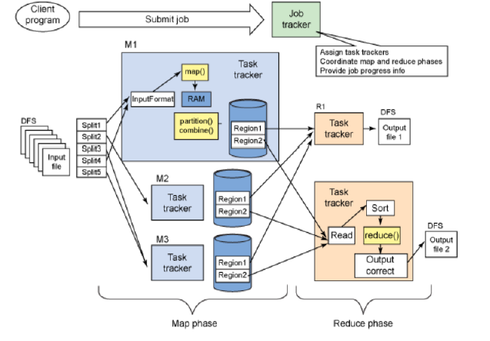
Fig. 2.1: Flow of map reduce algorithm

2.4 No-Sql Query Processing Tool on DFS
Spark is a no-sql query processing tool developed by Apache to process programs written in a high-level concise language and distributes the execution of its tasks onto DFS.
It achieves this through an API such as Data Frames and Datasets built atop Resilient Distributed Datasets (RDDs) – a distributed dataset abstraction that performs calculations on large clusters in a fault-tolerant manner.
Spark’s architecture differs from earlier approaches in several ways that improves its performance significantly:
a) Spark allows users to take advantage of memory-centric computing architectures by persisting DataFrames, Datasets, and RDDs in-memory, enabling fast iterative processing use case such as interactive querying or machine learning.
b) Spark’s high level DataFrames and Datasets APIs also enable further intelligent optimization of user programs.
c) Project Tungsten and Catalyst Optimizer as part of the Spark SQL engine significantly boosts spartk’s execution speed in many cases by 5-10 times.

2.5 Security Solution for Distributed File System
Apache Sentry [17], an open source project by Cloudera is an authorization module for Hadoop that offers the granular, role-based authorization required to provide precise levels of access to the right users and applications. It supports for role-based authorization, fine-grained authorization and multi-tenant administration [18].
Apache Knox Gateway is a system that provides a single point of authentication and access for various Hadoop services in a cluster. It provides a perimeter security solution for Hadoop. It supports various authentication and token verification scenarios. Knox manages security across multiple clusters and versions of Hadoop. It also provides SSO solutions, and allows integrating other identity management solutions such as LDAP, Active Directory (AD), and SAML based SSO and other SSO systems [19].
Project Rhino provides an integrated end-to-end data security solution to the Hadoop ecosystem [20]. It provides a token based authentication and SSO solution. It offers Hadoop crypto codec framework and crypto codec implementation to provide block level encryption for the data stored in Hadoop. It supports key distribution and management so that MR can decrypt data block and execute the program as per requirement. It also enhances the security of HBase by offering cell level authentication and transparent encryption for table stored in Hadoop. It supports audit logging framework for easy audit trails.

CHAPTER THREE
PROPOSED SYSTEM ARCHITECTURE
3.1 Proposed DFS
Our Proposed architecture consists of 1 master node with 3 slave nodes for distributed files systems to interconnect ISP log servers. HDFS exposes a file system namespace and allows user data to be stored in files. Internally, a file is split into one or more blocks and these blocks are stored in a set of Data Nodes. The Name Node executes file system namespace operations like opening, closing, and renaming files and directories. It also determines the mapping of blocks to Data Nodes. The Data Nodes are responsible for serving read and write requests from the file system’s clients. The Data Nodes also perform block creation, deletion, and replication upon instruction from the Name Node. The network connectivity among Name node and all Data Nodes can be described as below Fig. 3.1:

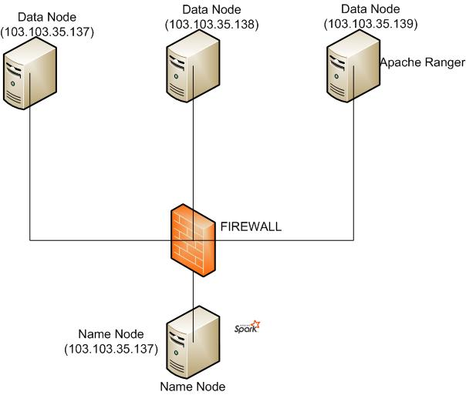
Fig. 3.1: Proposed DFS’s network architecture

According to the network architecture we have deployed one Name node with three slave nodes. In addition we have deployed apache spark at Name node and apache ranger at Data Node 2. The details of nodes and functionalities are described through Table 3.1:
Table 3.1: ISP log analytics Name Node and Data Node information
SL | Node Name | Disk Space | RAM | IP Address | Role
1 | Name Node | 50 GB | 12 GB | 103.103.35.137 | Name Node
2 | Data Node 1 | 50 GB | 12 GB | 103.103.35.137 | Data Node, Spark Server
3 | Data Node 2 | 50 GB | 7 GB | 103.103.35.138 | Data Node
4 | Data Node 3 | 50 GB | 7 GB | 103.103.35.139 | Data Node, Apache Ranger

ISP Log analytics uses a master/slave architecture in which one device (the master) controls one or more other devices (the slaves). The HDFS cluster consists of a single Name Node and a master server manages the file system namespace and regulates read, write access to files as Fig. 3.2. Master node is deployed in server: debian with ip address: 103.103.35.137.
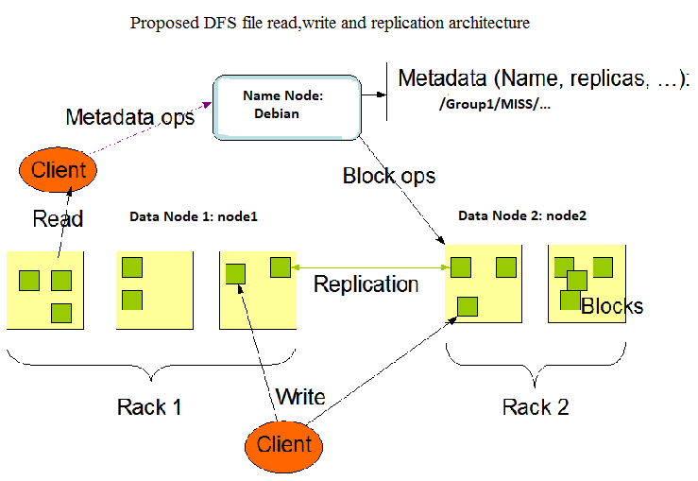
Fig. 3.2: Proposed distributed file system
Proposed DFS as shown in Fig.3.2 can store very large files across machines in a large cluster. It stores each file as a sequence of blocks; all blocks in a file except the last block are the same size. The blocks of a file are replicated for fault tolerance. The block size and replication factor are configurable per file. An application can specify the number of replicas of a file. The replication factor can be specified at file creation time and can be changed later. Files in proposed DFS are write-once and have strictly one writer at any time.
The Name node makes all decisions regarding replication of blocks. It periodically receives a heartbeat and a block report from each of the Data Nodes in the cluster. Receipt of a heartbeat implies that the Data Node is functioning properly. A block report contains a list of all blocks on a Data Node.
A Data Node stores data in the distributed file systems. A functional file system has more than one Data Node, with data replicated across them. On startup, a Data Node connects to the Name node and spinning until that service comes up. It then responds to requests from the Name Node for file system operations. Our proposed architecture will include all ISP’s as Data Node. Here Data Nodes are represented by debian, node1 and node2 respectively.
A network firewall protects a computer network from unauthorized access. It might take the form of a hardware device, a software program, or a combination of the two. We shall interconnect all isp as Data Node to Name node through VPN configuration at both source and destination (ISP’s). A virtual private network, or VPN, extends across a public or shared network, and acts like a tunnel so you can exchange data securely and anonymously across the internet as if you were connected directly to a private network.

3.2 Log Analysis over DFS
Spark runs on Hadoop, Apache Mesos, Kubernetes, standalone, or in the cloud. It can access diverse data sources. Spark powers a stack of libraries including SQL and Data Frames, MLlib for machine learning, GraphX, and Spark Streaming. We can combine these libraries seamlessly in the same application. We’ve deployed spark at master node ‘debian’ to process query over ISP internet access log in CSV format.
Apache Spark has had two core contexts that are available to the user. The sparkContext made available as sc and the SQLContext made available as sqlContext, these contexts make a variety of functions and information available to the user. The sqlContext makes a lot of DataFrame functionality available while the sparkContext focuses more on the Apache Spark engine itself. In our proposed deployment, Apache Spark 2 contains just one context - the SparkSession.
Databricks is a managed platform for running Apache Spark. Databricks also provides a host of features to help its users be more productive with Spark. It's a point and click platform for those that prefer a user interface like data scientists or data analysts. However, this UI is accompanied by a sophisticated API for those that want to automate aspects of their data workloads with automated jobs. To meet the needs of enterprises, Databricks also includes features such as role-based access control and other intelligent optimizations that not only improve usability for users but also reduce costs and complexity for administrators. Spark was originally written by the founders of Databricks during their time at UC Berkeley. The Spark project started in 2009, was open sourced in 2010, and in 2013 its code was donated to Apache, becoming Apache Spark.
In Spark, a DataFrame is a distributed collection of data organized into named columns. It is conceptually equivalent to a table in a relational database or a data frame in R/Python, but with richer optimizations under the hood. Data Frames can be constructed from a wide array of sources such as: structured data files, tables in Hive, external databases, or existing RDDs.

3.3 Access Control Policy Implementation
Apache Ranger is a framework to enable, monitor and manage comprehensive data security across the Hadoop platform. The vision with Ranger is to provide centralized and comprehensive security across the Apache Hadoop ecosystem using attribute based access control (ABAC). With the advent of Apache YARN, the Hadoop platform can now support true data lake architecture. Enterprises can potentially run multiple workloads, in a multi-tenant environment. Data security within Hadoop needs to evolve to support multiple use cases for data access, while also providing a framework for central administration of security policies and monitoring of user access. We have deployed access control policy using ranger from Node 2 and integrated log analytics’ yarn manager to ranger. Policies are set centrally and enforced by plugins. Plugins are simple libraries that run within data processing application and enforce policies enforces set in the policy manager. Apache Ranger goes beyond access control, with the ability to dynamically masking data when data is accessed in Hive.
Centralized policy management and distributed enforcement around various data processing and storage engines using ranger can be illustrated as Fig. 3.3:

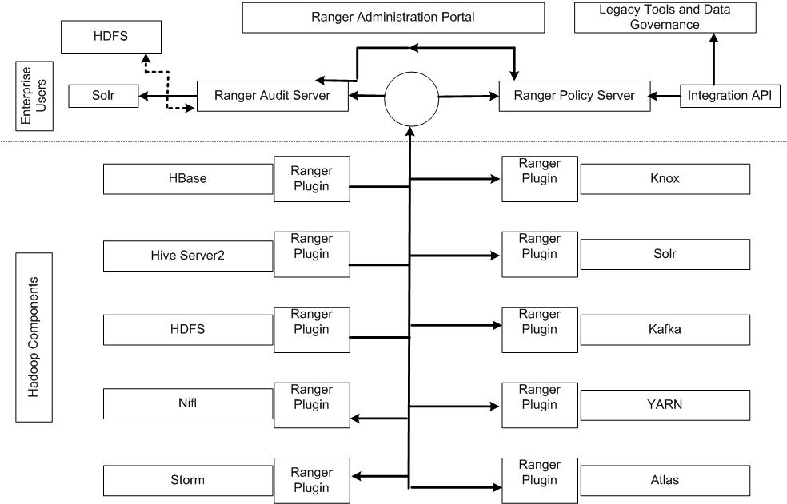
Fig. 3.3: Proposed security policy management

3.4 Security Features of DFS
Initial Hadoop distribution, Data Nodes do not enforce control. Due to this reason, the malicious user can read arbitrary Data Node blocks from Data Nodes and bypass the access control restrictions or write the garbage data in Data Nodes. Therefore, any user can submit a job to Job Tracker and could arbitrarily execute the job. The Hadoop community in Yahoo realized the security problem and enforced robust security controls through Kerberos as the authentication mechanism for Hadoop. The recent release of Hadoop 2.9 accomplished the goal using following security goals.

- Kerberos remote procedure call (RPC) for mutual authentication of users, their processes, and services.
- Web users implement their pluggable authentication called SPNEGO (Simple and Protected GSSAPI).
- Generic Security Service Application Program Interface and Negotiation Mechanism.
- Access control lists of users and groups on Hadoop files.
- Delegation tokens and subsequent authentication checks.
- Name Node takes access control decisions for Data blocks access.
- Job tokens enforce task authentication to ensure that tasks could do only assigned tasks.
- Enforce network level encryption to ensure quality of protection.

3.5 Environment Setup and Optimization
We have setup name and slave nodes in debian linux 8 [21] with Open JDK version 1.7. Apache Hadoop version 2.9 has been used to deploy distributed file system over three slave nodes. The features of environment can be illustrated as Fig. 3.4 with key features listed down as below:
- Debian Linux with OPEN JDK.
- Key based ssh connectivity between Master and Slave node.
- HOME and bash profile configuration for HDFS and Spark.
- HDFS file system format and directory for file processing.
- ISP log processing through SQL query based on requirements.
- Backup and recovery for Disaster management without centralized backup.
- Customization of environment.
- Apache Spark installation.
- Apache ranger implementation for access control policy.
- NTP synchronization to maintain accurate time across all ISP Data Node.

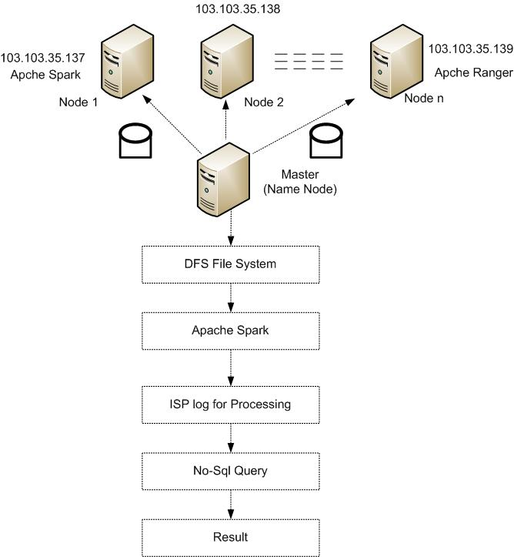

Fig. 3.4: Proposed DFS access control policy

3.6 Data Protection
Adequate security of information and information systems is a fundamental management responsibility. Nearly all applications that deal with financial, privacy, safety, or defense include some form of access (authorization) control. Access control is concerned with determining the allowed activities of legitimate users, mediating every attempt by a user to access a resource in the system. In proposed DFS, complete access is granted after successful authentication of the user, administrator with a predefined set of rules, policies and procedure. Security Features will be deployed using apace ranger 0.5.4 with MySQL database connected through mysql-connector-java. In addition, all data blocks will be replicated to maintain integrity and prevent data loss.
The infrastructure required to implement proposed DFS log analytics has been discussed in the chapter with required security measures in both network and system domain.

3.7 Proposed Log Format for ISP
In order to store all ISP log and merge into a single file, we have proposed a common log format. This format will include unique isp id having at least 4 digits and a subscriber id to be provided by his/her related isp. The individual isp log will be merged and rotated once a week or a month according to the total data volume. The common log format is provided as below Table 3.2:
Table 3.2: Proposed log format
SN | Field attribute | Description
1 | ISP ID: | ISP identification number
2 | Subscriber ID: | Subscriber identification number
3 | Name of Person / Organization | Full name of person or organization
4 | Address | Customer address
5 | Contact No | Customer phone number
6 | Alternate Contact No
7 | Email Address | Customer email address
8 | User ID for Internet Access based on authentication | Customer's user identification number
9 | IP Address Assigned | Customer's assigned real IP address
10 | Static / Dynamic IP Address Allocation | Natted IP address
11 | Source port of the public IP address in case of NATING | Source port for real IP address
12 | BST Start Time of IP Address Allocation (hh:mm:ss) | Timestamp in Bangladesh time
13 | BST End Time of IP Address Allocation (hh:mm:ss) | Timestamp in Bangladesh time

Log rotation policy will be determined according to retention policy and duration i.e., preserve log for six, twelve months or two years. For long duration, log rotation’s frequency will be executed frequently to maintain minimum space of any log file.
At the end, we shall merge all ISP’s log file to produce a single file called ‘NAT.csv’ for processing using below script as illustrated in Fig. 3.5:

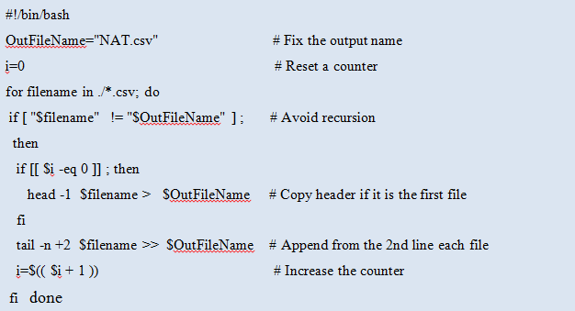

Fig. 3.5: ISP log merge script

CHAPTER FOUR
IMPLEMENTATION

4.1 Introduction
This chapter will cover detail explanations of configuration that is being used to make this project complete and working well. Section 4.2 gives an overview of master and Data Node environment. Section 4.3 describes necessary configuration for master node. Section 4.4 shows configuration for Data Nodes. Necessary configuration for apache spark is discussed in section 4.5. To ensure authorized access apache ranger is used and necessary configuration discussed in section 4.6. Section 4.7 describes configuration used to secure connectivity between nodes.

4.2 DFS Cluster Environment
Master and Data Nodes must have similar version of debian linux kernel and java or jre version for ideal hadoop’s distributed file system. For verification of debian linux and java version for master node and all Data Nodes, following commands can be executed as shown in the Fig. 4.1

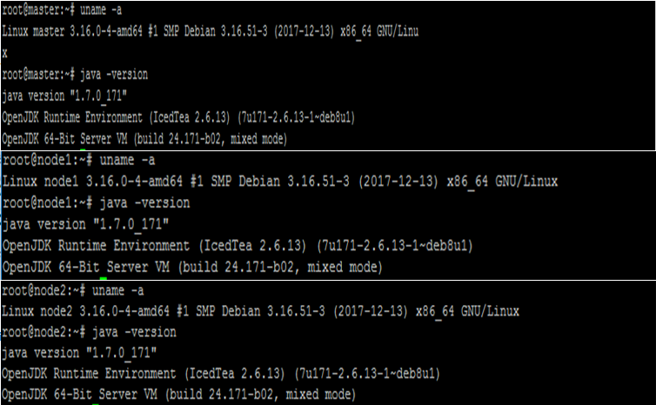

Fig. 4.1: Kernel and Java version of master and Data Nodes
4.3 Configuring Master Node
The master nodes in distributed Hadoop clusters host the various storage and processing management services. This section shows configuration for master node to make it fully functional.
4.3.1 Host File Configuration
For each node to communicate with its names, we have configured ‘/etc/hosts’ file at all three nodes to add the IP address of the three servers as Fig. 4.2


Fig. 4.2: Name and Data Node host file

4.3.2 Key-Based SSH Authentication Setup
The master node will use an ssh-connection to connect to other nodes with key-pair authentication, to manage the cluster without password. The key based password less SSH connectivity [22] among three nodes will be configured using below steps from master node as illustrated as below:
- Login to node-master as the hadoop user, and generate an ssh-key.
- ssh-keygen -b 4096.
- Copy the key to the other nodes. Its good practice to also copy the key to the node-master itself, so that you can also use it as a Data Node if needed. Type the following commands, and enter the hadoop user’s password when asked. If you are prompted whether or not to add the key to known hosts, enter yes.
- ssh-copy-id -i $HOME/.ssh/id_rsa.pub debian@node-master.
- ssh-copy-id -i $HOME/.ssh/id_rsa.pub debian @node1.
- ssh-copy-id -i $HOME/.ssh/id_rsa.pub debian @node2.

4.3.3 User Profile Configuration
Add Hadoop binaries. Edit /home/hadoop/.bashrc file and add the following line
as Fig. 4.3:

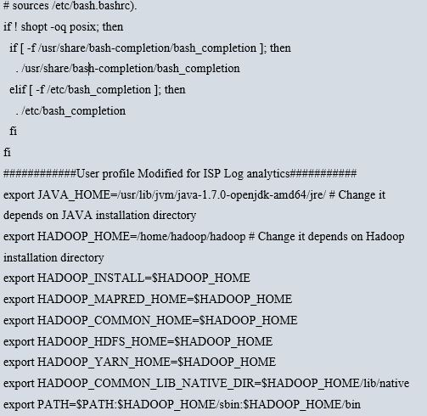

Fig. 4.3: User profile configuration
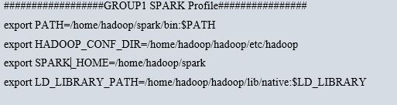
For spark running on hadoop deployment, additional configuration will be appended to user profile at node-master as provided in Fig. 4.4:

Fig. 4.4: Spark user profile
4.3.4 Set Java Home
We have installed Open JDK version 1.7 with default Java runtime environment. The java path must be defined for user profile as below:
‘/usr/lib/jvm/java-1.7.0-openjdk-amd64/jre/’

4.3.5 ISP Log Analytics Core Site Configuration
On master node update ~/hadoop/etc/hadoop/core-site.xml and set the Name Node location to node-master on port 9000 as Fig. 4.5:
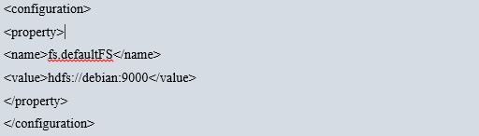
Fig. 4.5: Core site configuration

4.3.6 Synchronization of Binary and Data Directory
From master node ‘debian’ we shall execute below commands to synchronize node 1 and 2 hadoop binary installation directory:
# rsync -avzh /home/hadoop/ hadoop@node1:/home/hadoop/
# rsync -avzh /home/hadoop/ hadoop@node2:/home/hadoop/

4.3.7 Configuration of Data Block Replication Parameter
For configuration of default directory for Name and Data node to store meta data and user information, hdfs-site file will be edited. The file is located under etc. directory. After modification of the file, formatting the DFS file system is required. Edit ‘/home/hadoop/hadoop/etc/hadoop/hdfs-site.xml’ as Fig. 4.6 at master node to configure Name Node, Data Node and replication of data blocks among Data Nodes:
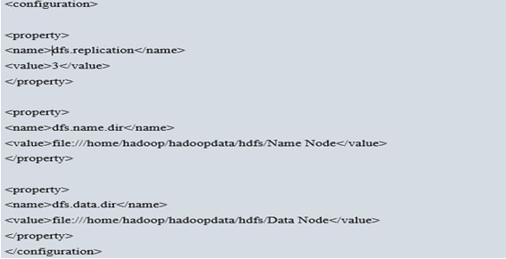
Fig. 4.6: HDFS site configuration

4.3.8 Configuration of Yarn as Job Scheduler
Under ~/hadoop/etc/hadoop/ directory, rename mapred-site.xml.template to mapred-site.xml. Edit the file as Fig. 4.7, setting yarn as the default framework for Map Reduce operations:
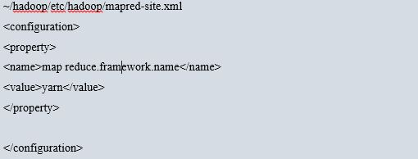

Fig. 4.7: Mapred-site configuration

Edit yarn-site.xml as illustrated in Fig. 4.8:
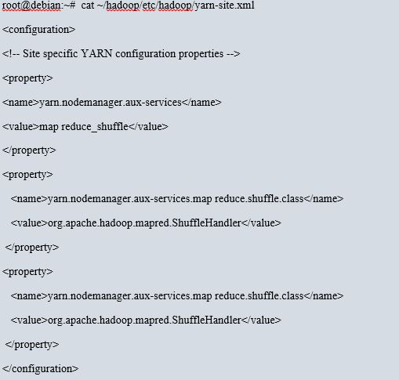

Fig. 4.8: Yarn site configuration

4.4 Configuration of Data Nodes
The file slave is used by startup scripts to start required daemons on all nodes. Edit ~/hadoop/etc/hadoop/slaves as Fig. 4.9:
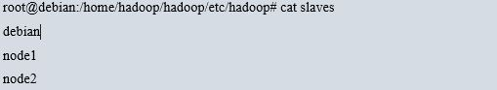

Fig. 4.9: Slave node configuration

4.5 Apache Spark Configuration
Apache Spark has been downloaded and extracted under hadoop user’s home directory using common hadoop user at Master node. Under the spark/bin directory run the ./spark-shell and load databricks for csv file processing as Fig. 4.10:
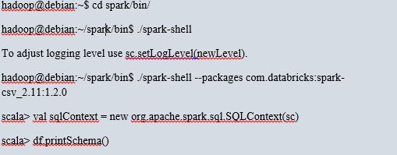 Fig. 4.10: CSV databrick loading configuration
The resulting output of df.printSchema() will provide all column’s information for any log file in CSV format. Spark’s job execution, completed SQL query’s duration can be monitored from web gui using url http://103.103.35.137:4040 as Fig. 4.11:

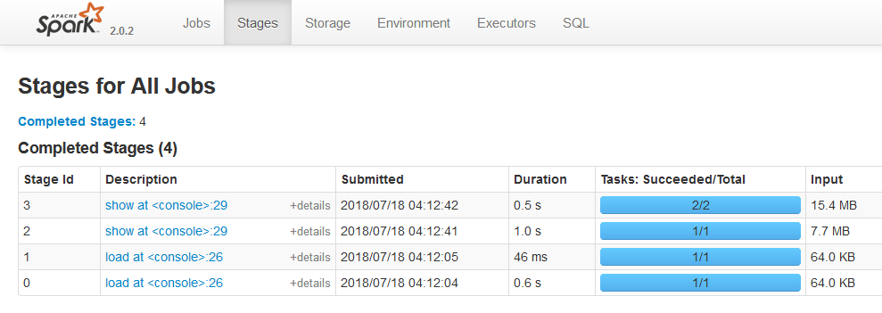Fig. 4.11: Apache Spark Web Gui

4.6 Implementation of Access Control using Apache Ranger
Apache Ranger has been installed and configured in third node of distributed file system and integrated with Log analytics. The Ranger administration portal can be accessed using url: 103.103.35.139:6080 as Fig. 4.12:
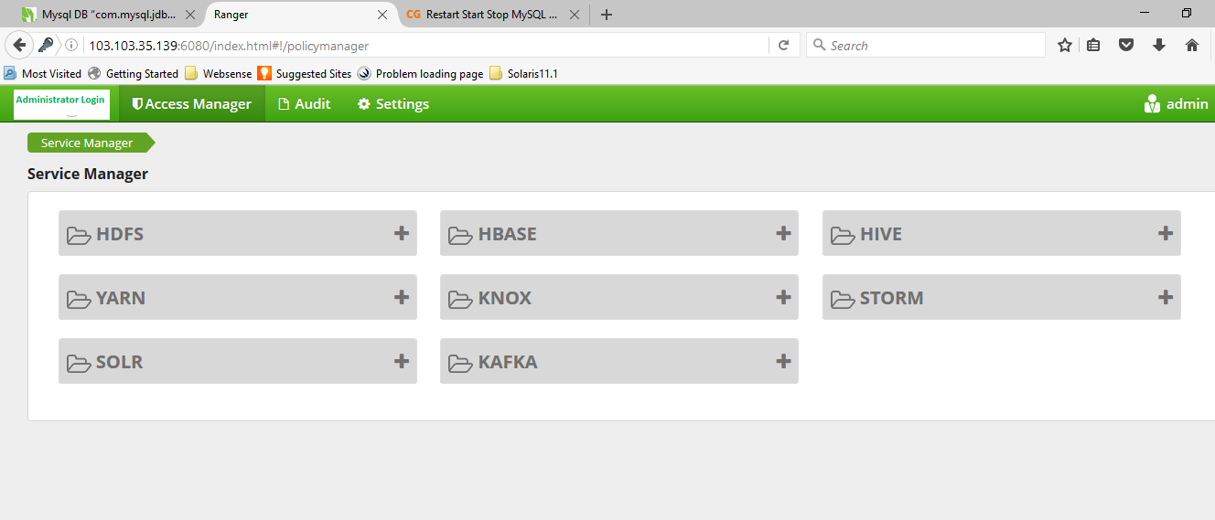
Fig. 4.12: Log analytics Access Control Policy’s Dash board
User named Shazzad and Mahfuz has been created with admin and user role as Fig. 4.13:
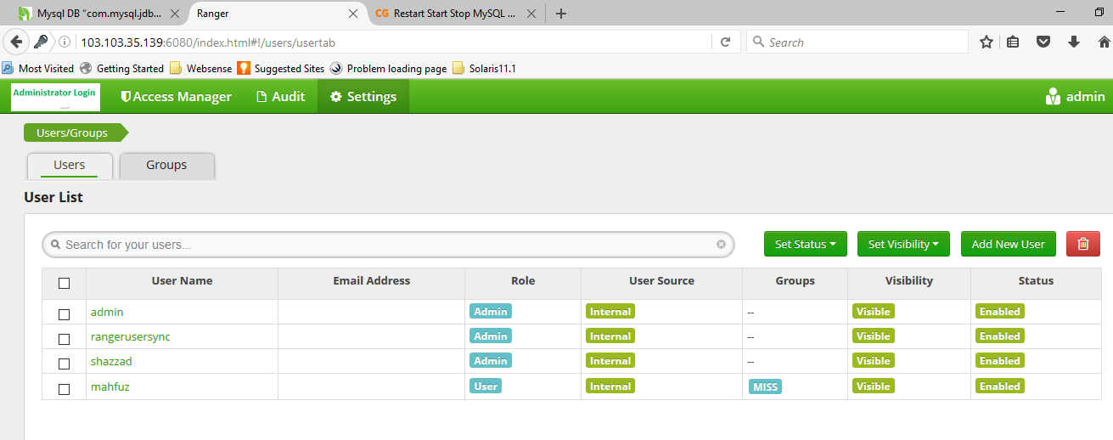
Fig. 4.13: Log analytics User and Group information
From above Fig. 4.13, user name, role and status can be verified and add, delete, modification of privileges can be done. Audit of administrator and user activity can be accessed from the mentioned web page.

4.7 Secured Connectivity among Nodes
In order to ensure secured communication among name node and all Data Nodes, we shall apply following best practices for configuration of VPN and IPTABLE [23] in participating hosts:
- Enable Host Based Firewall.
- Allowed Required Ports i.e. 50070, 8088, 6080 and Restrict or deny access to all other ports,
firewall-cmd --permanent --add-port=50070/tcp
firewall-cmd --permanent --add-port=8088/tcp
iptables -A INPUT -p tcp --dport 50070 ACCEPT
iptables -A INPUT -p tcp --dport 8088 ACCEPT
iptables -A INPUT -p tcp --dport 6080 ACCEPT
firewall-cmd --reload
- Configure IPSec tunnel between Master and Slave Nodes as Fig. 4.14:
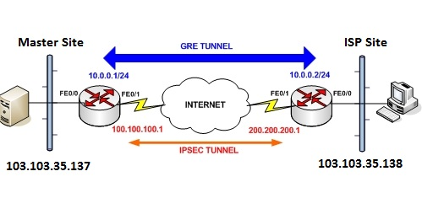Fig. 4.14: IPSec over GRE Tunnel conFig.uration between Master and one ISP site

- Define Access Control List (ACL) to allow only master and slave nodes.
- Use Strong Cryptography key and Passphrase for tunnel configuration.
- Allow Authorized user or administrator to modify or update network configuration and log activities.
- Arrange for secondary or backup link connectivity between Name node and each Data Node.
4.8 Setup and Configure NFS for benchmarking
To setup NFS mounts for performance comparison with proposed DFS, 1 NFS server with 3 clients will be configured:
NFS Server: master node with ip address: 103.103.35.137
NFS Client: Data Node 1 with ip address: 103.103.35.137
NFS Client: Data Node 2 with ip address: 103.103.35.138
NFS Client: Data Node 3 with ip address: 103.103.35.139
For sharing a directory with NFS, an entry is required in “/etc/exports” configuration file.
A new directory named “isplog” in “/” partition will be created to share with client server using below commands in unix vi editor:
# vi /etc/exports
/isplog 103.103.35.137 (rw,sync,no_root_squash)
At the NFS client end i.e, from Data Node 2, check the nfsshare using below commands:
# showmount -e 103.103.35.137
Export list for 103.103.35.137:
/isplog 103.103.35.138
Above command shows that a directory named “isplog” is available at server having IP address “103.103.35.137” to share with Data Node 2.
To mount that shared NFS directory at the client’s node, following command will be used:
# mount -t nfs 103.103.35.137:/isplog /mnt/isplog
CIFS mount point will be configured in the same way for performance comparison in next chapter.

CHAPTER FIVE
SIMULATION AND RESULT
5.1 Introduction
In this chapter, the architecture and relevant configuration of the proposed DFS will be used to simulate and evaluate the performance of the file systems, query processing and security features. To evaluate the performance of log processing, a comparison between proposed query processing method and map reduce will be performed. ISP log will be used by Spark utility to perform search based on specific attribute and the latency of read, write operations shell be recorded in proposed DFS, NFS and CIFS shares respectively to draw performance comparison.

5.2 Data Collection
Our proposed solution will process user’s internet activity log real-time and for that purpose we have collected ISP user’s log from 2 ISP. User access log contains required information about Client’s name, contact address, phone no., Source IP Address, Destination IP Address, MAC Address, Source Port, Destination Port, Logging time. Sample of user’s activity log is provided as below Table 5.1:
Table 5.1: Sample ISP user internet activity log
Date Time | Client IP | Src Port | Dst IP | Dst Port | Pop Name | Protocol
00:59.0 | 54.255.166.250 | 80 | 10.254.27.206 | 39389 | Cyber-POP-104.30 | TCP
00:59.0 | 10.254.31.76 | 51906 | 31.13.79.63 | 443 | Cyber-POP-104.30 | TCP
00:59.0 | 10.254.27.19 | 42978 | 47.88.65.224 | 6798 | Cyber-POP-104.30 | TCP
00:59.0 | 172.217.166.106 | 443 | 10.254.27.237 | 60589 | Cyber-POP-104.30 | TCP
00:59.0 | 43.245.142.146 | 443 | 10.254.31.202 | 38215 | Cyber-POP-104.30 | TCP
00:59.0 | 10.254.63.230 | 9101 | 123.134.94.228 | 9310 | Cyber-POP-104.30 | UDP
00:59.0 | 31.13.79.36 | 443 | 10.254.27.54 | 53146 | Cyber-POP-104.30 | TCP
00:59.0 | 10.254.63.230 | 9101 | 58.56.111.24 | 9310 | Cyber-POP-104.30 | UDP
00:59.0 | 172.217.163.129 | 443 | 10.254.47.88 | 41857 | Cyber-POP-104.30 | TCP

5.3 Monitor HDFS Cluster
Standard unix commands for administration can be executed to review health status locally. In addition, we can get useful information about run-time status of HDFS cluster with the HDFS dfsadmin command. Try for example:
#hdfs dfsadmin -report
The Name Node offers a summary of health and performance metrics through an easy-to-use web user interface. By default, the page is accessible via port 50070, so type the address in a web browser as http://103.103.35.137:50070 as like Fig. 5.1:

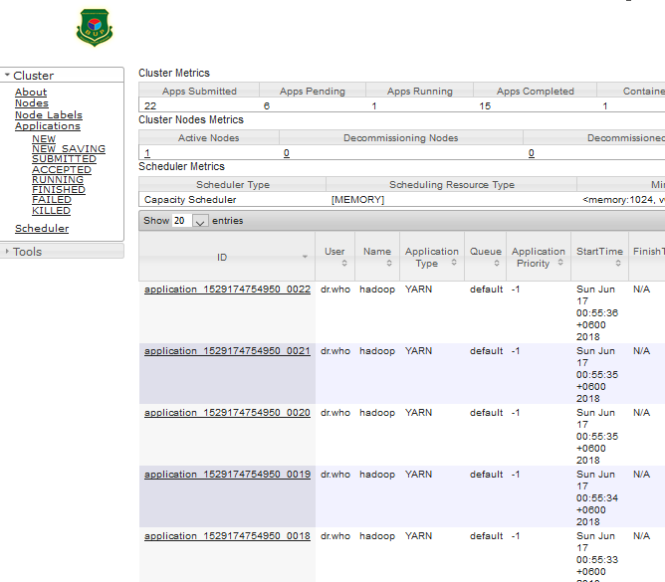

Fig. 5.1: HDFS Cluster Monitoring

5.4 Experiments with Proposed Method
From below query using Spark’s scala command shell, we can identify the client communicating with destination POP address as Table 5.2 where connected clients source, source port, destination IP address, destination port no. and POP id through which the clients connect to internet are displayed.
scala> df.select("ClientIP","Src_Port","Dst_IP","Dst_Port","Pop_Name").show()
Table 5.2: Scala output of clients connected with source, destination and pop name

ClientIP | Src_Port | Dst_IP | Dst_Port | Pop_Name
54.255.166.250 | 80 | 10.254.27.206 | 39389 | Cyber-POP-104.30
10.254.31.76 | 51906 | 31.13.79.63 | 443 | Cyber-POP-104.31
10.254.27.19 | 42978 | 47.88.65.224 | 6798 | Cyber-POP-104.32
172.217.166.106 | 443 | 10.254.27.237 | 60589 | Cyber-POP-104.33
43.245.142.146 | 443 | 10.254.31.202 | 38215 | Cyber-POP-104.34
10.254.63.230 | 9101 | 123.134.94.228 | 9310 | Cyber-POP-104.35
31.13.79.36 | 443 | 10.254.27.54 | 53146 | Cyber-POP-104.36
10.254.63.230 | 9101 | 58.56.111.24 | 9310 | Cyber-POP-104.37
172.217.163.129 | 443 | 10.254.47.88 | 41857 | Cyber-POP-104.38
10.254.63.230 | 9101 | 65.254.40.44 | 9310 | Cyber-POP-104.39
10.254.63.230 | 9101 | 192.200.108.26 | 9310 | Cyber-POP-104.40
10.254.63.230 | 9101 | 27.221.103.4 | 9310 | Cyber-POP-104.41
10.254.31.223 | 53185 | 157.240.16.39 | 443 | Cyber-POP-104.42
52.222.236.16 | 443 | 10.254.27.229 | 59111 | Cyber-POP-104.43
10.254.27.110 | 34704 | 54.192.159.111 | 443 | Cyber-POP-104.44
10.254.63.230 | 9101 | 78.129.239.6 | 9110 | Cyber-POP-104.45
172.217.166.98 | 443 | 172.168.31.223 | 35210 | Cyber-POP-104.46
172.217.166.98 | 443 | 172.168.31.223 | 35210 | Cyber-POP-104.47
172.217.166.98 | 443 | 172.168.31.223 | 35210 | Cyber-POP-104.48
172.217.166.98 | 443 | 172.168.31.223 | 35210 | Cyber-POP-104.49
172.168.32.15 | 56247 | 103.217.105.211 | 443 | Cyber-POP-104.50
10.254.63.230 | 9101 | 27.221.103.11 | 9110 | Cyber-POP-104.51
10.254.31.223 | 53186 | 157.240.16.39 | 443 | Cyber-POP-104.52

From below query we can identify any specific client’s having MAC address: “84:16:f9:b0:3a:5b” with different ISP and Destination as Fig. 5.2:
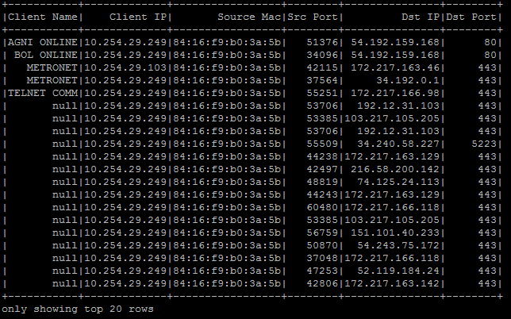
Fig. 5.2: Scala output of apache spark framework for MAC based query

5.5 Comparison between Proposed Method and Map Reduce
Proposed Spark can do processing in memory, while Hadoop MapReduce has to read from and write to a disk. As a result, the speed of processing differs significantly, Spark may be up to 100 times faster. However, the volume of data processed also differs.
Spark is used in proposed DFS architecture which performs faster in comparison to map reduce because it supports in-memory processing and this becomes very useful in iterative computing of big data. Spark comes with many cluster manager options such as Amazon EC2, Standalone, Mesos and Yarn. Spark’s performance over map reduce may be obtained with work count programs performance which was tested and result provided in Fig. 5.3:
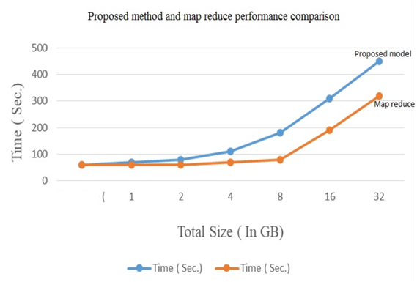
Fig. 5.3: Comparison between proposed method and map reduce (3 Instances)
From Fig. 5.3 the analysis used 10 Data Nodes and processed upto 48 GB data and comparison of required time by hadoop’s map reduce and spark are shown in the graph as blue (Hadoop) and red or orange (Spark).
5.6 Comparison with Present Scenario of ISP Log
Currently government bodies and law enforcement agencies tracing a user’s internet access activity through a distributed process. This is very time consuming and success rate is very low. ISP’s are not able to maintain user internet access log with details and there is no backup or redundant copy of user log. The log is not preserved for long duration. They may modify the log and hide information. In our proposed system, logs will sync real-time. We have shown a comparison below.
In current scenario law enforcement agencies query to ISP for logs, System administrator may manipulate the log and hide information. Also there can be some human error in provided data. In our proposed solution, government agencies can perform their query directly into the system; there will be no dependency to other people which will ensure the accuracy of the data.
In current process data is requested through mail or in written paper which may expose those data to unauthorized people. In our proposed system all the ISP’s are connected to central Name Node through a secured network channel and law enforcement agencies are performing their query centrally. They don’t need to share the data in mail or paper. This will ensure the integrity of the information.
All the ISP’s will be connected through a secured channel. Data will be authentic. ISP’s and users cannot deny the information in the log.
In current process it may take 15/20 days to collect information for all the ISP’s. In our proposed solution log can be retrieved in a secured manner in less than one second.
5.7 Monitor Access to ISP Log Analytics Using Proposed Solution
In order to impose restrictions on logging into ISP log server’s master node, we have implemented access control using Apache Ranger where user and group are defined with specific privileges. We can monitor user session from ranger’s audit menu as Fig. 5.4:
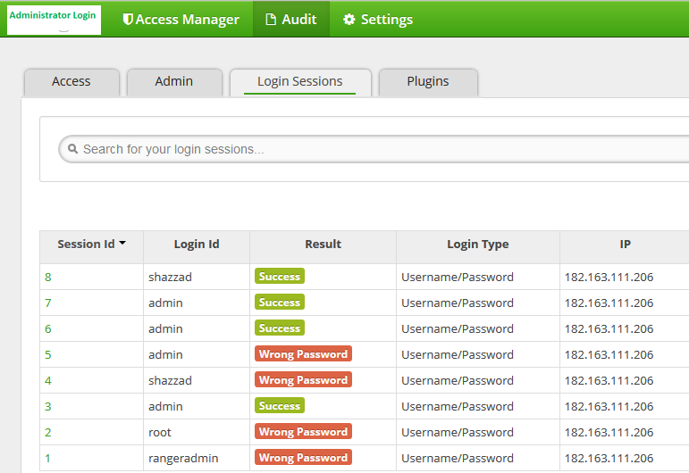
Fig. 5.4: User activity monitor
5.8 Performance benchmarking of Proposed DFS over NFS and CIFS
Fig. 5.5 shows that using proposed DFS provides much better read latency over NFS and CIFS. For 100 GB data read operation, latency of proposed DFS is lower than that of CIFS and NFS.
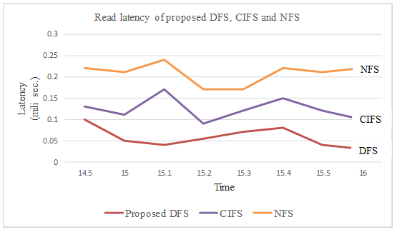
Fig. 5.5: Read latency of proposed DFS, CIFS and NFS

Fig. 5.6 shows that using proposed DFS provides much better write latency over NFS and CIFS. For 100 GB data write operation, latency of proposed DFS is lower than that of CIFS and NFS.
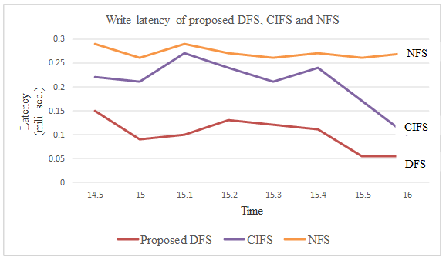
Fig. 5.6: Write latency of proposed DFS, CIFS and NFS

5.9 Security Comparison of Proposed DFS over NFS, CIFS
Security comparison among NFS, CIFS and proposed DFS can be described as below Table 5.3:
Table 5.3: Security comparison among NFS, CIFS and proposed DFS
File System | NFS | CIFS | Proposed DFS
Architecture | File-based protocol | File-based protocol | Cluster based
Processes | Stateless | Stateful | Stateful
Naming | No central metadata server | No central metadata server | Central metadata server
Synchronization | No synchronization | No synchronization | Write-one-read-many, give locks on objects to clients, using leases
Session Requirement | No | Yes | Yes
Communication speed | Fast | Slow | Fast
Fault Tolerance | No | No | Yes
Security mechanism | No | Kerberos | Security in the form of AAA

From Table 5.3 it is found that the architecture of NFS and CIFS is file based protocol but proposed DFS is cluster based. NFS has stateless process, CIFS and proposed DFS have stateful process. There is no central metadata server for NFS and CIFS except proposed DFS. There is no synchronization in NFS and CIFS. Communication speed is fast in both NFS and proposed DFS. There is no security mechanism in NFS, kerberos in CIFS and AAA security in proposed DFS.

CHAPTER SIX
CONCLUSIONS AND FUTURE WORKS
6.1 Conclusion
In Perspective of Bangladesh we have designed a centralized log analytics system to access and monitor user’s activity in internet using commodity hardware and open source software for cost optimization and rapid deployment. Since the generated log by all ISP exceeds regular computing storage and processing power, the best big data solution using Distributed file system has been used for the project. Throughout the chapter 2 and 3, we have collected present status of ISP user log preservation and retention policy in our country and drawn comparison with neighborhood and European Union. In chapter 4, we implemented ISP log analytics using Apache hadoop with spark and ranger. Network security required for communication among master and all nodes has been discussed. A sample script to merge all ISP log into a single csv file has been included which will be rotated according to log retention policy. The csv file has been used in experiments for specific purpose. Finally, all experiment results regarding log analytics distributed file system implementation, map reduce algorithm, no-sql query and access control features have been included in chapter 5. The log analytics system offers flexibility and ability to process large datasets. Our proposed solution will ensure authorized access and protect user’s privacy.

6.2 Major Contribution and Recommendation for Future Works
In future Govt. regulatory agency may benefit from our system for conducting investigation on cybercrime or generate statistics relating to internet usage. Our proposed solution will also preserve user activity log for a long duration to detect and investigate suspicious activity that occurred a long time ago. Through implementation of one master node and three slave nodes we have simulated our design and performed search for any user’s internet activity. We have also implemented fundamental security features and proposed optimized usage of resources. Where volume, velocity and verity of data set is a challenge for processing and beyond normal processing capacity, our proposed architecture can be implemented with comprehensive storage and retention period. In future following development can be performed on ISP log analytics DFS:
- Software defined perimeter (SDP) might be used here for securing communication channel between master node and Data Node.
- Two-factor authentication might be used for administrative users.
- Our proposed platform could be migrated into Docker platform for maximum utilization in current hardware setup.
- Migration of the proposed solution to cloud infrastructure.

REFERENCES

[1] | A. S. Tanenbaum and M. Steen, Distributed Systems: Principles and Paradigms. Prentice Hall, Upper Saddle River, NJ, 2003.
[2] | Hugh Darwen, An Introduction to Relational Database Theory. Frederiksberg, Denmark: Ventus Press, 2009.
[3] | Brent Callaghan, NFS Illustrated. Berkeley, CA: Addison-Wesley Professional Press, 1999.
[4] | Liu Jiang, Bing Li, and Meina Song, “The optimization of HDFS based on small file”, In Proc. 3rd IEEE International Conference on Broadband Network and Multimedia Technology ’09,2010, pp. 912-915.
[5] | G.Saranya, Dr.V.Janardhan babu, and G.Hemanth Kumar, “High Performance Analytics of Bigdata Using Hadoop Framework,” Journals of Advanced Research in Computer Science and Software Engineering, vol. 8, issue 4, May, pp. 200-203, 2018.
[6] | Bangladesh Telecommunication Regulatory Commission (BTRC), “BTRC License Summary”, btrc.gov.bd, pdf file, Feb. 13, 2019. [Online]. Available: http://www.btrc.gov.bd/license-summary-0. [Accessed Oct. 12, 2018].
[7] | CoreStack, “The Log Mandate Enabling Indian ISPs to adhere to DoT compliance rules”, corestack.io, para. 1-2, June 1, 2017. [Online]. Available: https://www.corestack.io/blog/the-log-mandate-enabling-indian-isps-to-adhere-to-dot-compliance-rules/ [Accessed Oct. 15, 2018].
[8] | A. Chowdhury, M. Chowdhury, and M. Imran, "Branding strategies for service firms- a study on the selected Internet Service Providers (ISPs) in Bangladesh", Journals of Asian Business Review, vol. 2, no. 1, 2015. Available: http://oaji.net/articles/2014/800-1398831499.pdf. [Accessed June. 2018].
[9] | European Union, Directive 2006/24/EC of the European Parliament and of the Council. Brussels, Belgium: Office of Headquarters Operations, 2006.
[10] | Internet Service Providers Association Bangladesh (ISPAB), “ISPAB Members”, ispab.org, html file, Feb. 13, 2019. [Online]. Available: https://www.ispab.org/members/. [Accessed June 5, 2018].
[11] | Tom White, Hadoop:The Definitive Guide,4th ed. Reading, MA: O’Reilly Media, Inc.,2015. The.Definitive.Guide.4^{th.}Edition.2015.pdf Available: amazonaws e-book.
[12] | Donald A. Lewine, POSIX Programmer’s Guide,1st ed. Reading, MA: O’Reilly Media, Inc.,1994. OReilly_POSIX_Programmers_Guide.pdf Available: O’Reilly e-book.
[13] | Pete Loshin, TCP/IP Clearly Explained. San Francisco, California: Morgan Kaufmann Publishers, 1998.
[14] | Brian n. Bershad, Thomas e. Anderson, Edward d. Lazowska and Henry m. Levy, “Lightweight Remote Procedure Call,” ACM Transactions on Computer Systems, vol. 8, no. 1, Feb., pp. 37-55.
[15] | Anurag Sarkar, Abir Ghosh and Dr. Asoke Nath, “MapReduce: A Comprehensive Study on Applications, Scope and Challenges,” International journal of Advance Research in Computer Science and Management Studies,vol. 3, no. 7, pp. 255-271, 2015.
[16] | Tripti Mehta, and Neha Mangla,“A Survey Paper on Big Data Analytics using Map Reduce and Hive on Hadoop Framework,” Journal of Advanced Research in Computer Science and Software Engineering, vol.5, issue 7, July, pp.1153-1157, 2015
[17] | Priya P. Sharma, and Chandrakant P. Navdeti, “Securing Big Data Hadoop: A Review of Security Issues, Threats and Solution,” Journal of Computer Science and Information Technologies, vol. 5(2), May, pp. 2126-2131, 2014.
[18] | Lin H., Seh S., Tzeng W., and Lin B.P., “Data Confidentiality via Integrating Hybrid Encryption Schemes and Hadoop Distributed File System” In Proc. 26th IEEE International Conference on Advanced Information Networking and Applications, ’03,2012, pp.745-747.
[19] | M.ChithikRaja, and M.MunirAhamed Rabbani, “Comprehensive and Coordinated Security of Knox gateway in Big Data,” Journal of Advance Research in Science and Engineering, vol.4, issue 3, March, pp. 61-69, 2015.
[20] | Cloudera, “Project Rhino Goal: At-Rest Encryption for Apache Hadoop”, cloudera.com, para. 2, June 17, 2014. [Online]. Available: https://blog.cloudera.com/blog/2014/06/project-rhino-goal-at-rest-encryption/ [Accessed Oct. 20, 2018].
[21] | Martin Felix Krafft, The Debian System. San Francisco, USA: No Starch Press, 2005.
[22] | SSH Communications Security, Inc., “SSH (Secure Shell) home”, ssh.com, Apr. 13, 2018. [Online]. Available: https://www.ssh.com/ssh/. [Accessed Apr 15, 2018].
[23] | Oskar Andreasson, “Iptables Tutorial 1.2.2”, frozentux.net, Dec., 2006. [Online]. Available: https://www. frozentux.net /iptables-tutorial/. [Accessed May 25, 2018].
[24] | Sayalee Narkhede, and Tripti Baraskar, “Analyze Web Application Logs over Hadoop Map Reduce,” International Journal of UbiComp (IJU), vol. 4, no.3, July, pp. 41-51, 2013.

